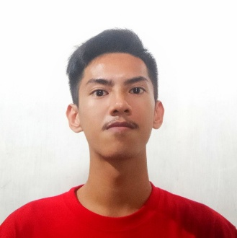**MILES VINCENT SERRA**

Phase 7A Package 10 Block 22 Lot Excess

Caloocan, Philippines, 1428

+639509468605

milesvincentserra@gmail.com

**Career Objective:** To be able to reach the level of knowledge

through new opportunities and share experiences,

qualities and talents in line with work.

# **PERSONAL INFORMATION**

**Age** : 19

**Birth Date** : August 06, 2002

**Height** : 165 cm.

**Weight** ; 53 kg.

**Gender** : Male

**Citizenship** : Filipino

**Civil Status** : Single

**Language** : English, Filipino

# **EDUCATIONAL background**

**College (Undergraduate) St. Vincent de Ferrer College of Camarin 2020 - 2022**

**BS Information Technology**

**Camarin, Caloocan City**

**Senior High School St. Vincent de Ferrer College of Camarin 2018 - 2020**

**TVL Track and Computer Programming Strand**

**Camarin, Caloocan City**

**Junior High School Benigno Aquino Jr. High School 2014 - 2018**

**Caloocan City**

**Elementary Pag – Asa Elementary School 2008 - 2014**

**Caloocan City**

# **work experience**

**Primeline Paper Sales Inc. Machine Operator (Paperbag) Dec. 2022 - ????**

**Canumay East, Valenzuela City**

**Paravisible Builders Inc. Construction worker (Labor) Feb. 2021 - Sept. 2021**

**Fairview, Quezon City**

**St. Vincent de Ferrer ICT Intern Dec. 2019 - Mar. 2020**

**College of Camarin**

**Caloocan City**

**Titanic Cargo Handlers Helper (Pahinante) May 2017 - Jan. 2018**

**Imus, Cavite**